**Write a C program to implement Stack operations such as PUSH, POP and PEEK**

**INPUT:**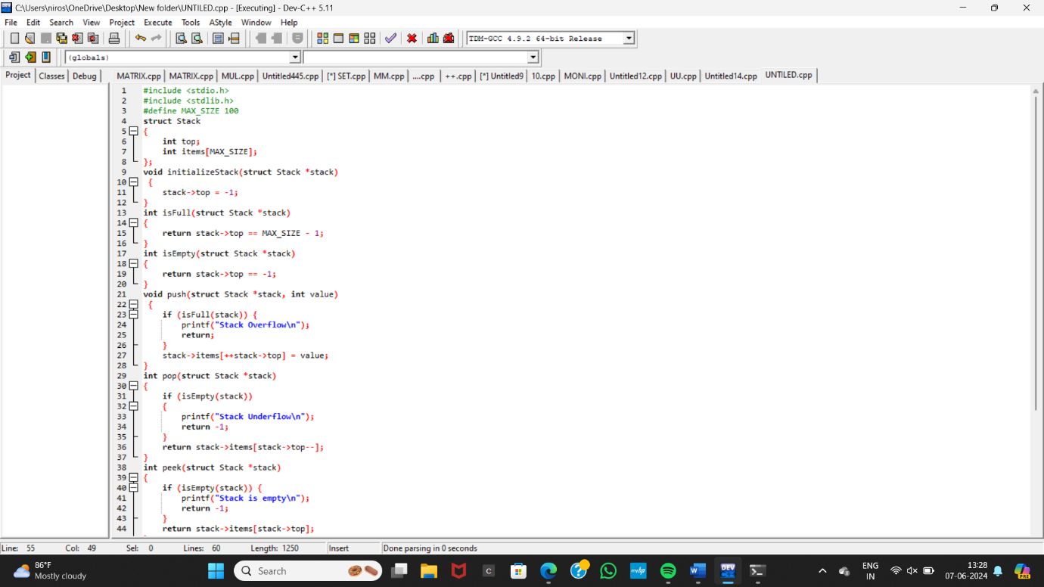

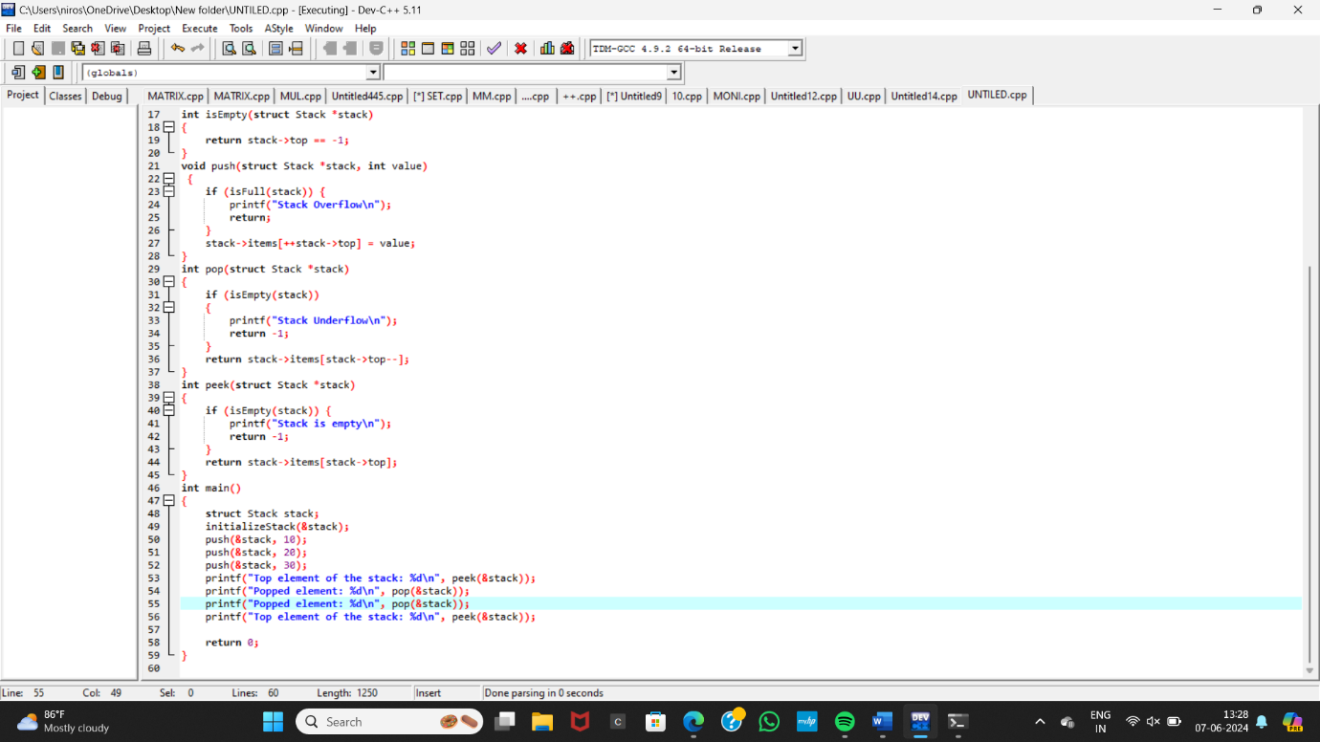

**OUTPUT:**

